First Name: ___________________________

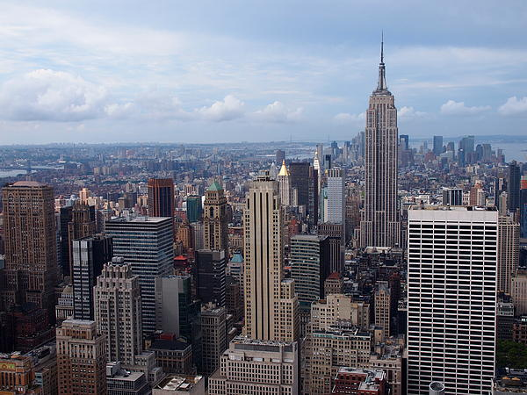 | My New York City  Your Job: Research and create a model of a New York City Landmark.

What is the name of your landmark? ___________________________________________________

Where is your landmark located? ______________________________________________________

When was your landmark built? _______________________________________________________

Who built your landmark? What was the name of the architect? ______________________________

What are three interesting facts that you read about your landmark?

Draw a full-color picture of your landmark  in the space below. | Why did you pick this landmark?  What do you like about it?  _________________________________  _________________________________  _________________________________  _________________________________  _________________________________  _________________________________  _________________________________  _________________________________

